OTT App Using Django

*In this app user can watch movies , web series and all. but user have to purchase any subscription plan. We have models for store content , users, subscriptons, app settings etc. so admin can manage everything hassel free without coding knowledge.*

**Software & Installation:**

1)Python ->3

2)VS Code or PyCharm

**Installation :**

Install Django => pip install Django==2.2.3

Install => pip install razorpay==1.2.0

Install => pip install django-mathfilters==1.0.0

**File Structure :** MUVI**(Main Project Folder)** 🡪 MYAPP **(This Is Our App Folder Where We Store Views,Models,Templates).**

Then go inside main app **(MUVI Folder)** using cmd **(cli)** and run command python manage.py runserver **(So It Will Run Your App).**

**About This Application**

**Admin:** In This Project Admin Can Add Subscription Plans, Add Content & Content Type, Watch User Details.

**User:** User Watch Content By Taking Subscription Plan.

**Login Signup Feature**

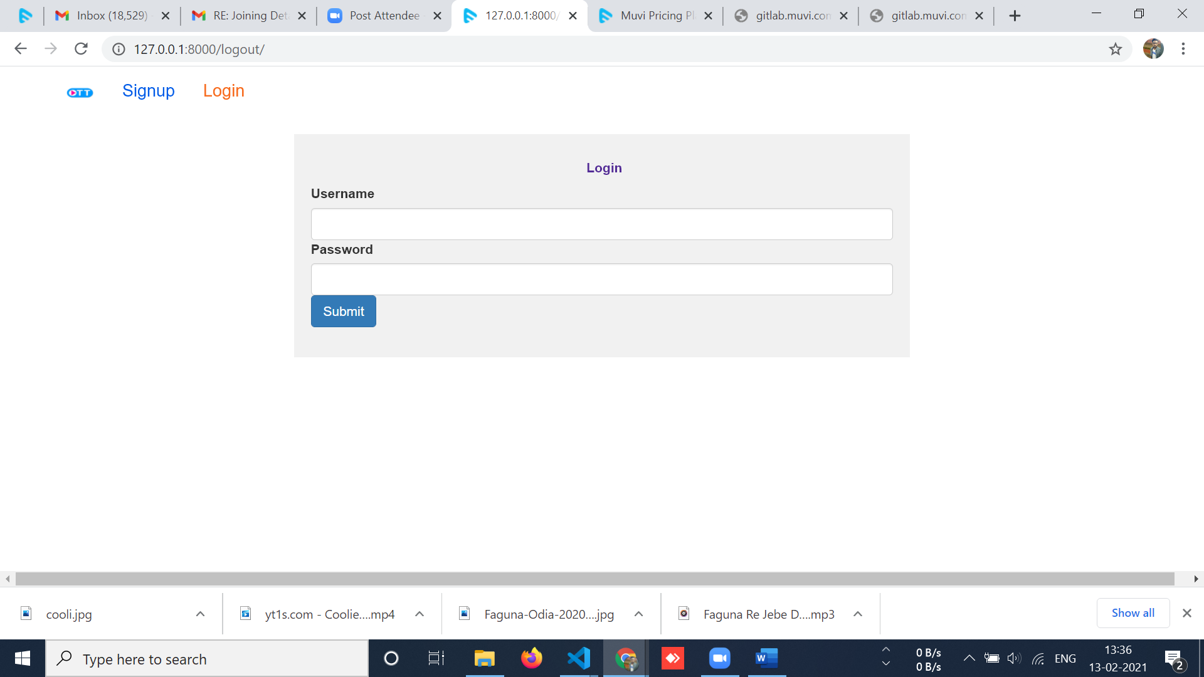

**Home Page:**

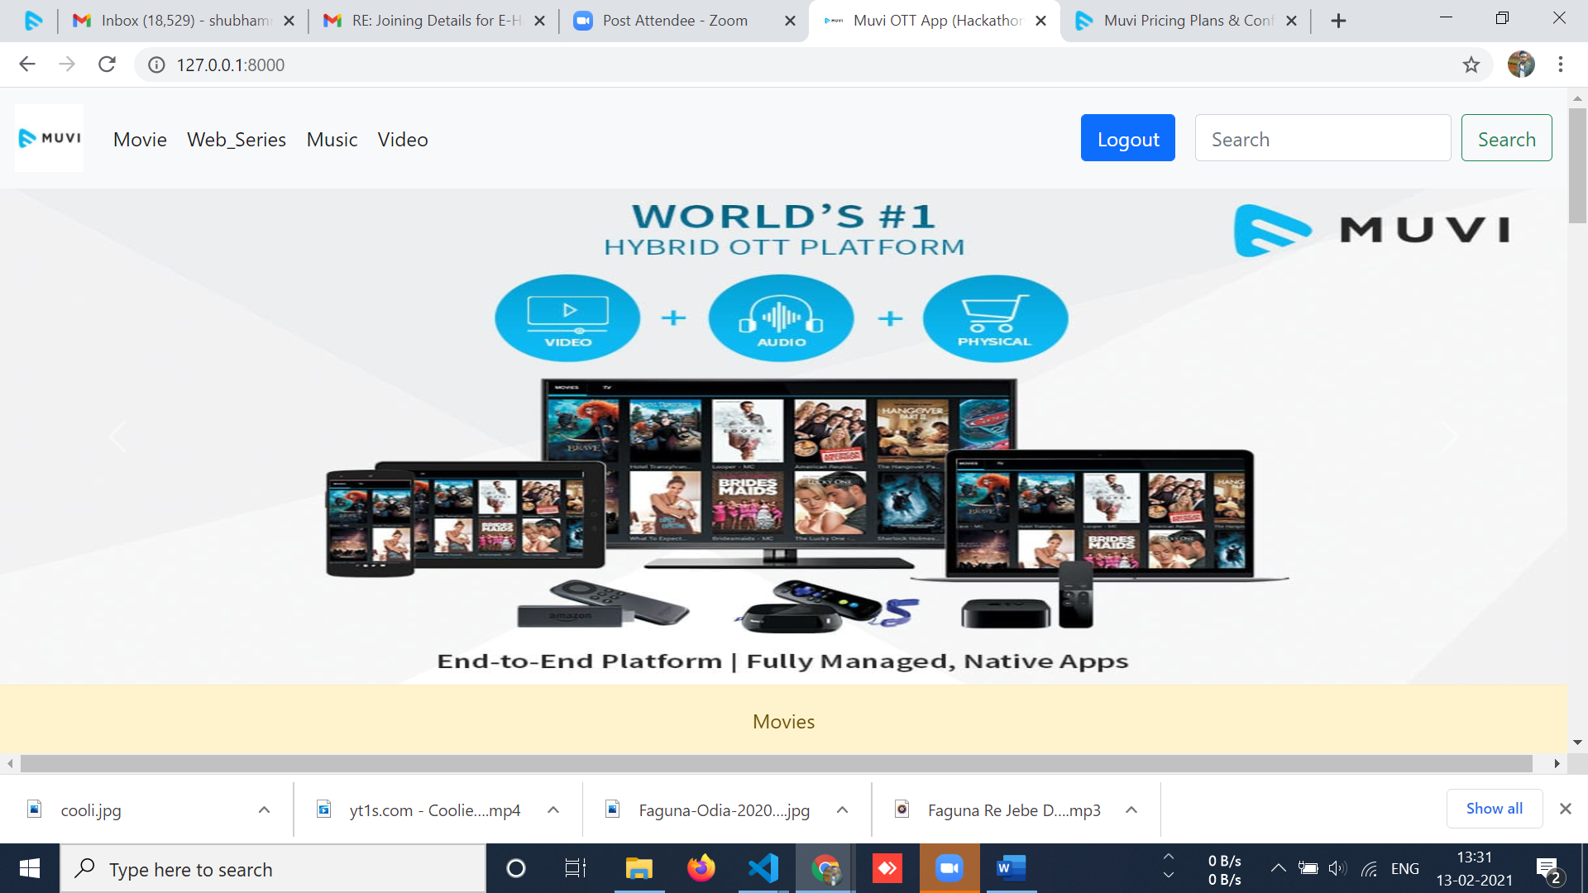

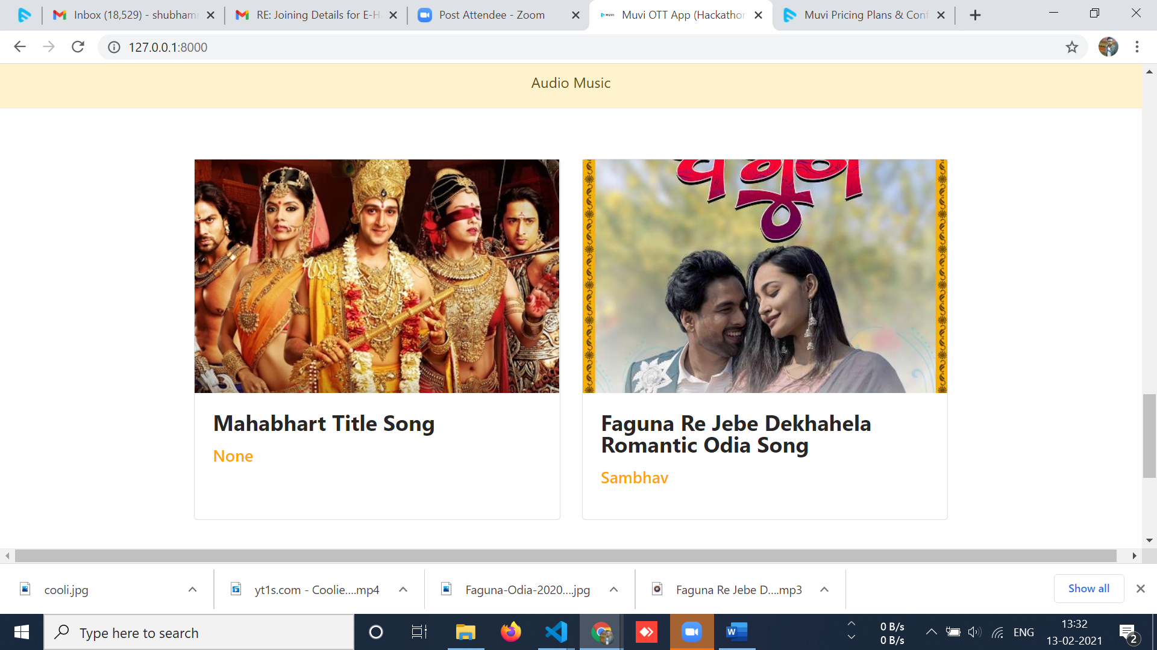

**Subscriptions:**

**If User Is Not Purchase Any Plans So This Model Open. Otherwise It Will Redirect To Details Page.**

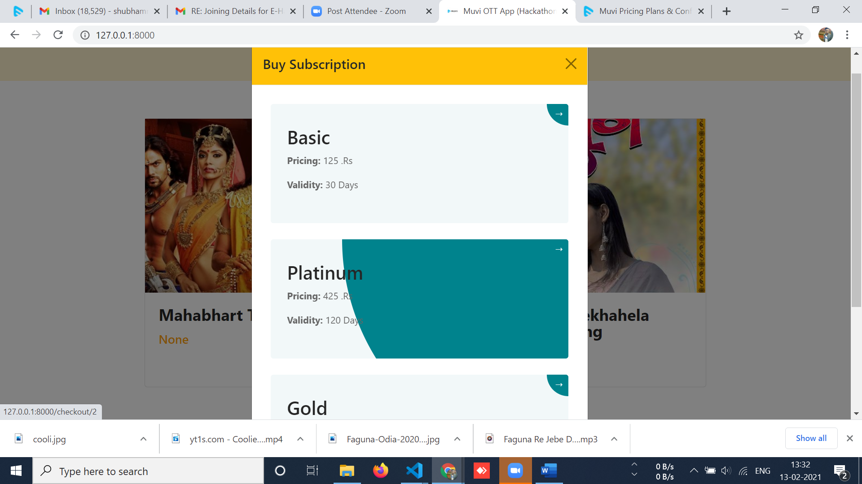

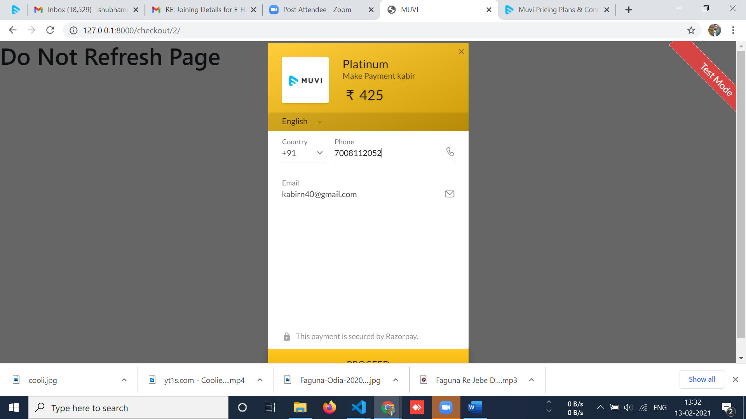

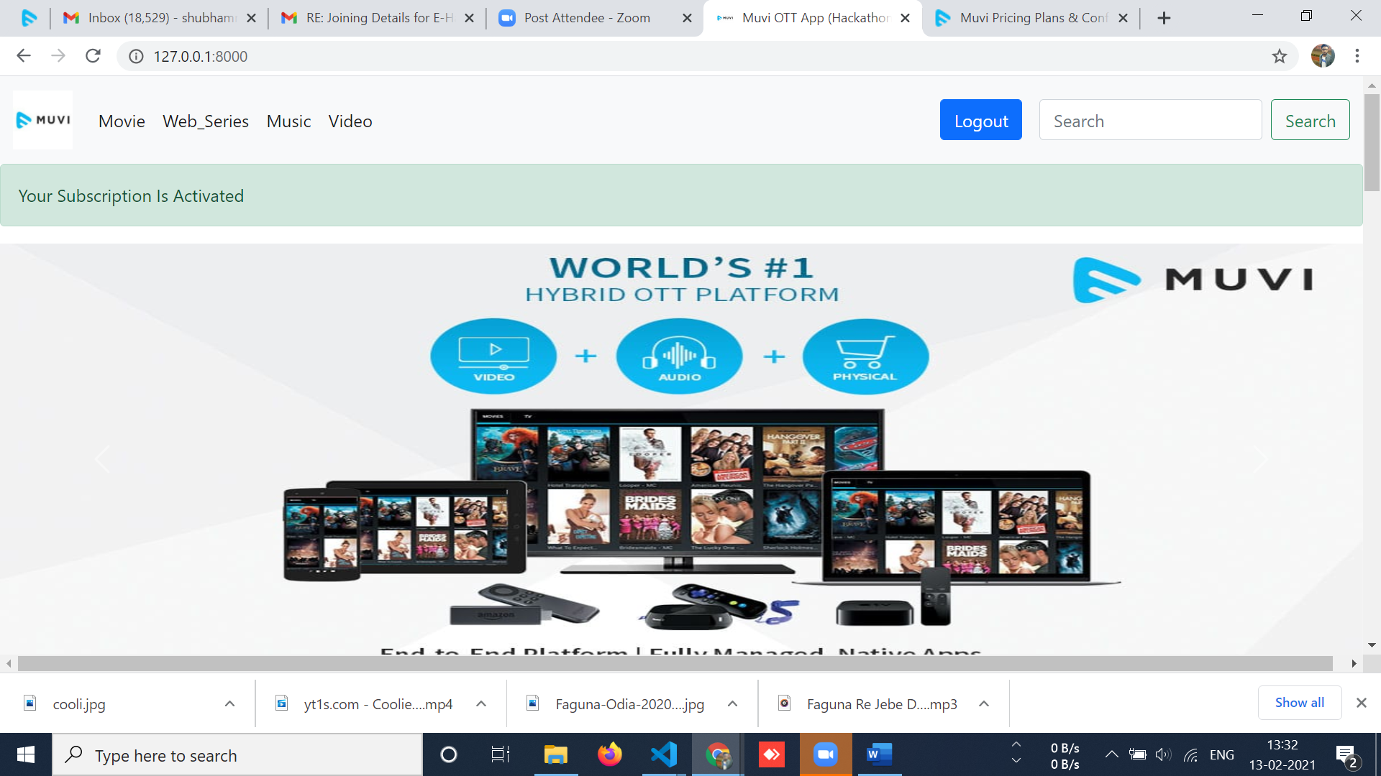

**Details Page:**

After Purchase You Will Able To Access Content.

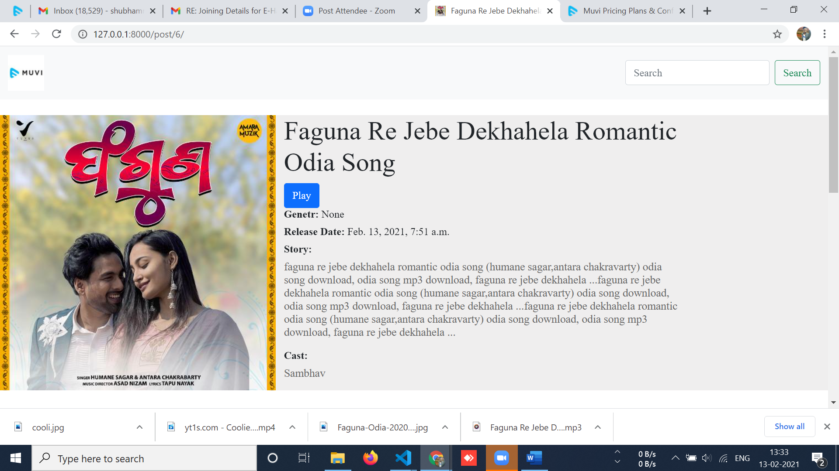

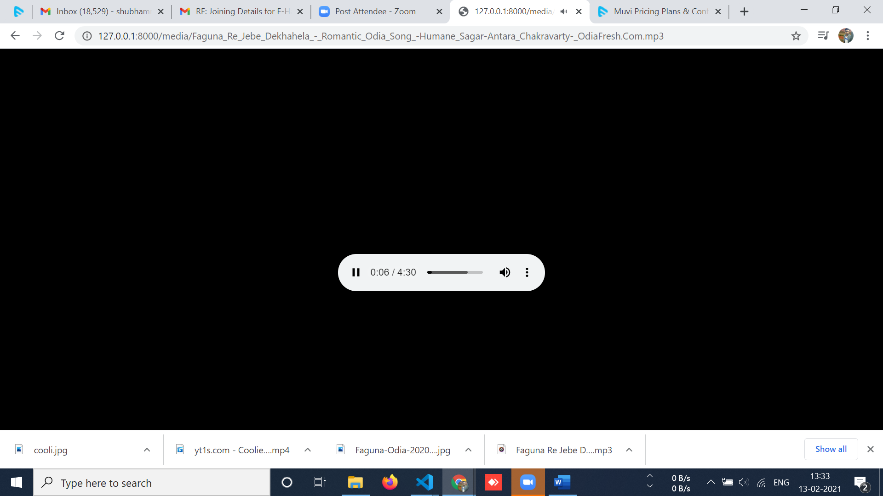

**Admin Page:**

**Username:muviadmin**

**Password:123**

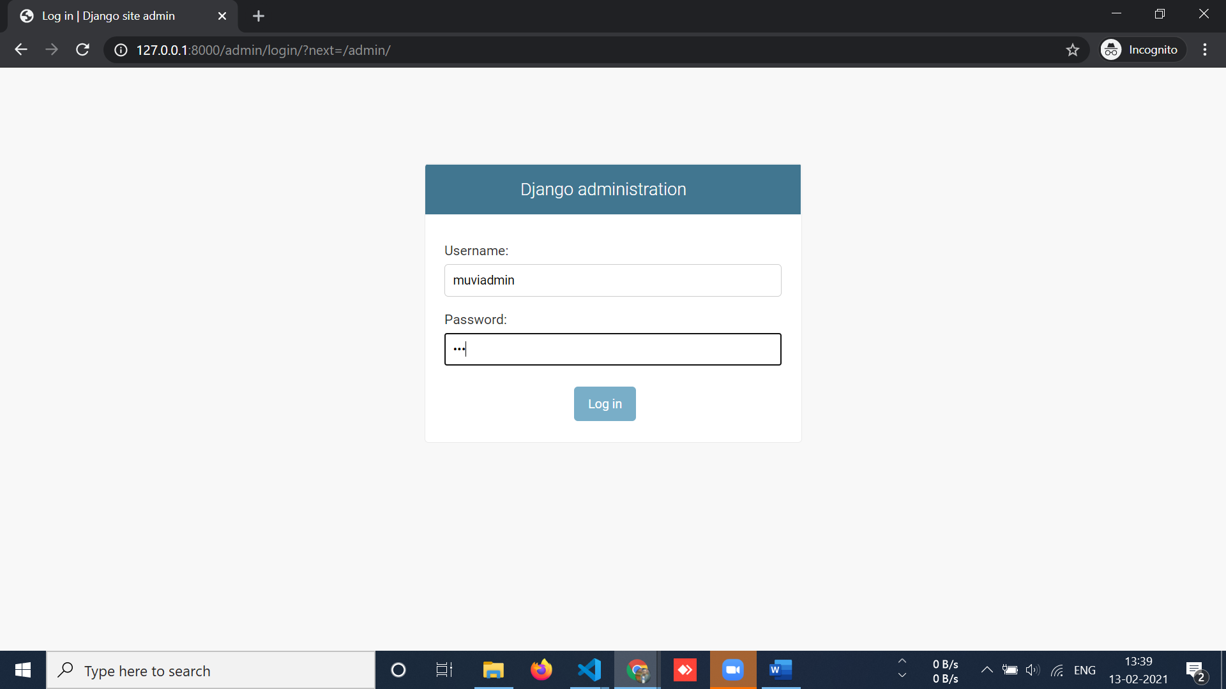

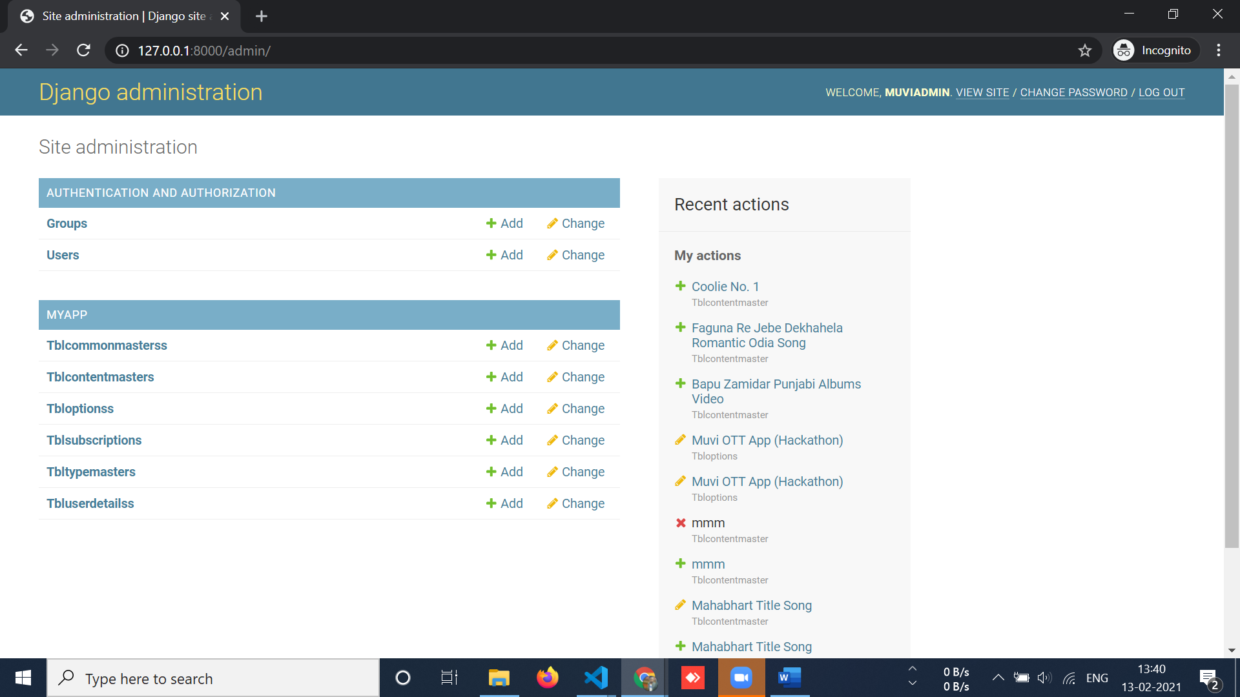

**Banners Uploaded**

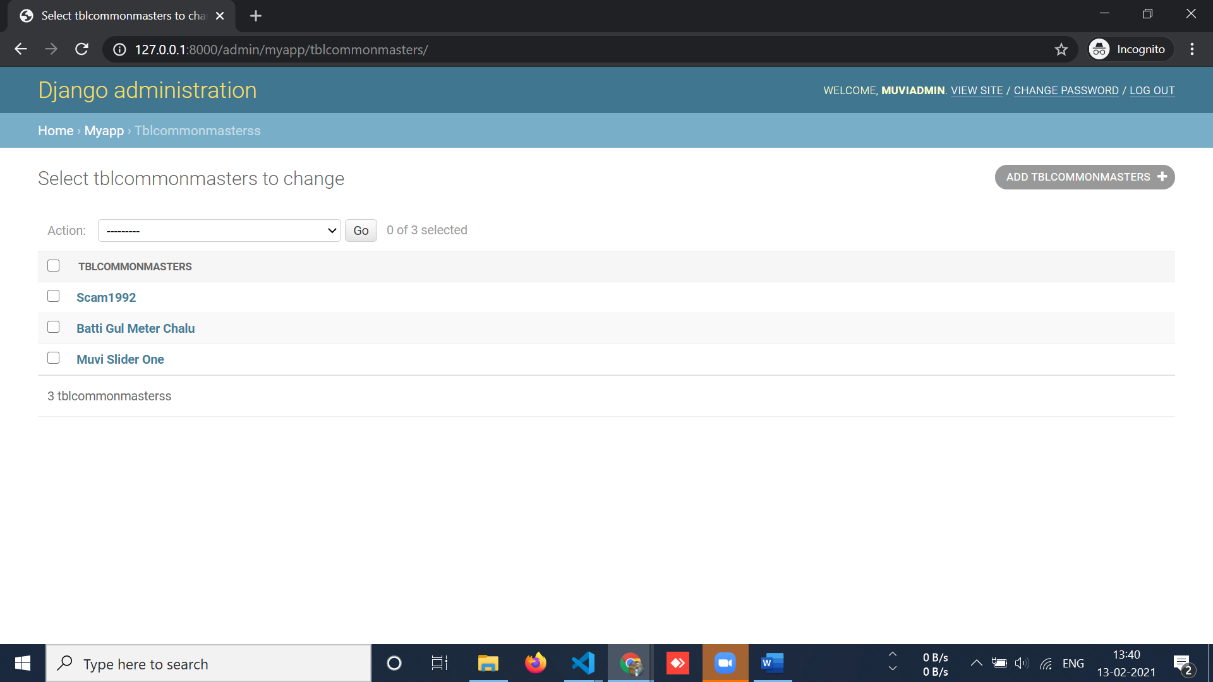

**Contents Uploaded**

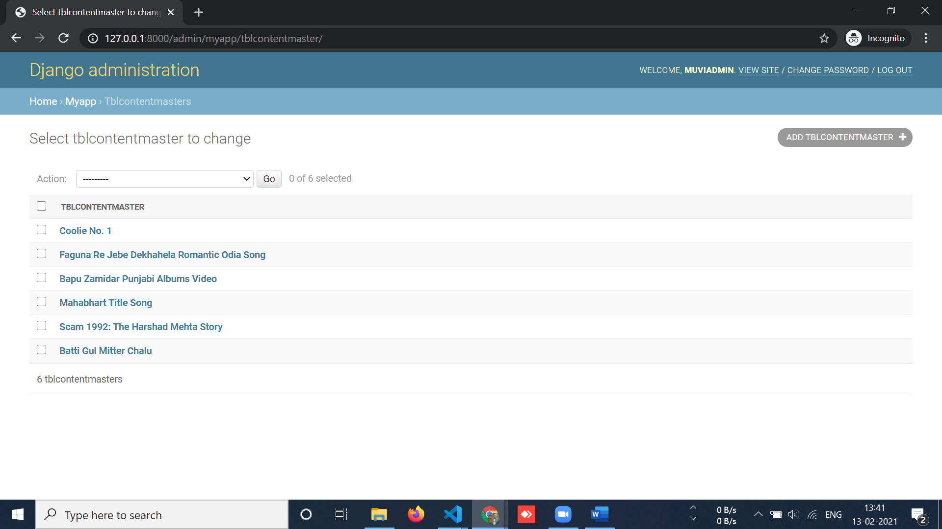

**Subscriptions**

